**CPT105 2020 Coursework 3 Part C** **– Design Document**

Name : Chuanxin.zhai

Student ID : 1929631 Date : 2020.12.12

**Class Diagram of the Picture Class** :

Class diagram

- imagine: BufferedImage

- frame: Jframe

- filename: String

- width: final int

-height: final int

+ Picture (int width, int height)

+Picture (String name)

+ show(): void

-getJLabel(): JLabel

+ height(): int

+width(): int

+getColor(int col, int row): Color

+setColor(int col, int row, Color color): void

- validateRowIndex(int row): void

- validateColumnIndex(int col): void

- getRGB(int col, int row): int

- setRGB(int col, int row, int rgb): void

+ toString():String

+ equals(Object other): boolean

**Description of Part B.1 positionalTransform method** : **(100-150 words)**

Title of your positional transform special effect : Attractive handsome boy called zhai

Description of the positional effect :

I used my personal pictures to do the position effect. My positional effect has a variety of effect, such as wave effect, mirror effect and upside-down effect. It makes me look like an attractive boy. Hahaha!

Description of the steps taken to achieve that positional effect :

-1. I create a new coverage to compare conveniently.

-2. I change the pixel of each row along the sine curve with the “for” loop to make the wave effect.

-3. In the “for” loop, it contains mirror effect and upside-down effect by changing the location of the pixels.

-4. Returning the new picture in the right side to compare with the original picture on the left side.

-

-

**Description of Part B.2 colorTransform method** : **(100-150 words)**

Title of your color transform special effect : Red fuzzy handsome boy called zhai

Description of the color effect :

I also used my personal pictures to do the color effect. My color effect has both negative color effect and see-through-a-glass effect. And I highlight the red color. It makes my pictures look like a red fuzzy handsome boy.

Description of the steps taken to achieve that color effect :

-

-1. I create a new coverage to compare conveniently.

-2. I change the color into negative color with two “for” loops.

-3. In this loop, I also highlight the red color of my personal pictures.

-4. After that, I create the see-through-a-glass effect by exchanging the pixel with random surrounding pixels in the “for” loop.

-5. Returning the new picture in the right side to compare with the original picture on the left side.

**Sample Picture 1 of Part B.1 Positional Transform** : **(before/after)**

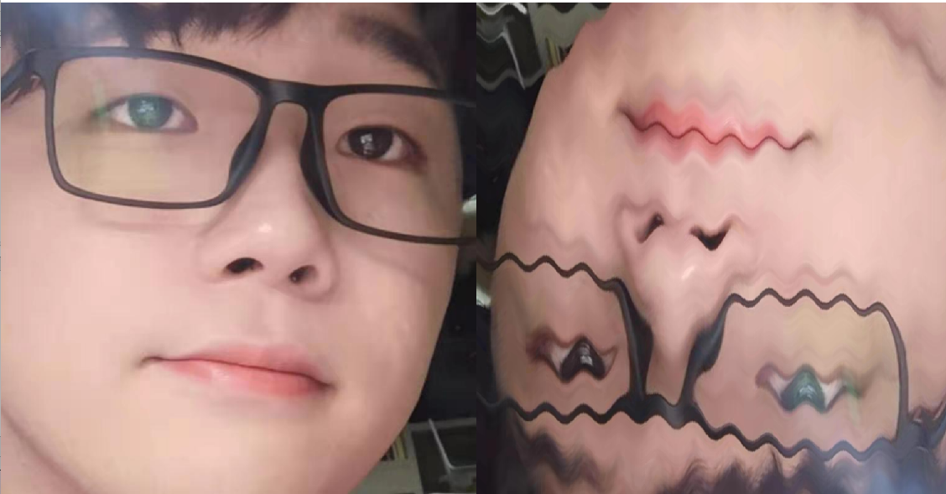

**Sample Picture 2 of Part B.1 Positional Transform** : **(before/after)**



**Sample Picture 3 of Part B.1 Positional Transform** : **(before/after)**

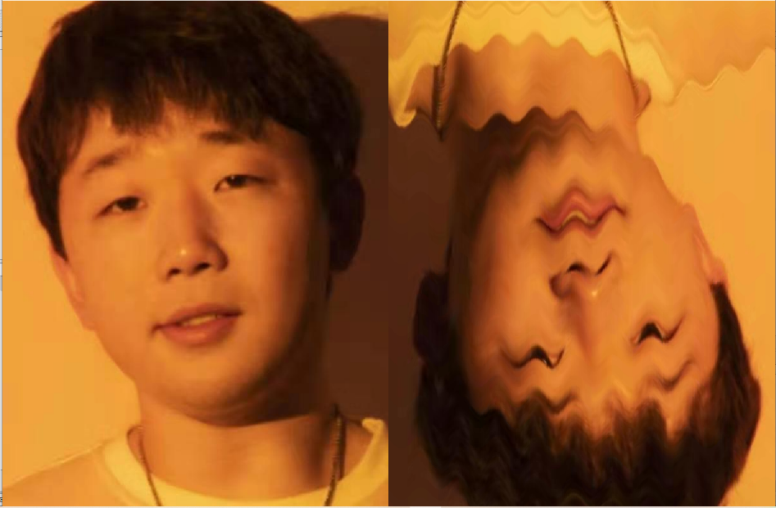

**Sample Picture 1 of Part B.2 Color Transform** : **(before/after)**

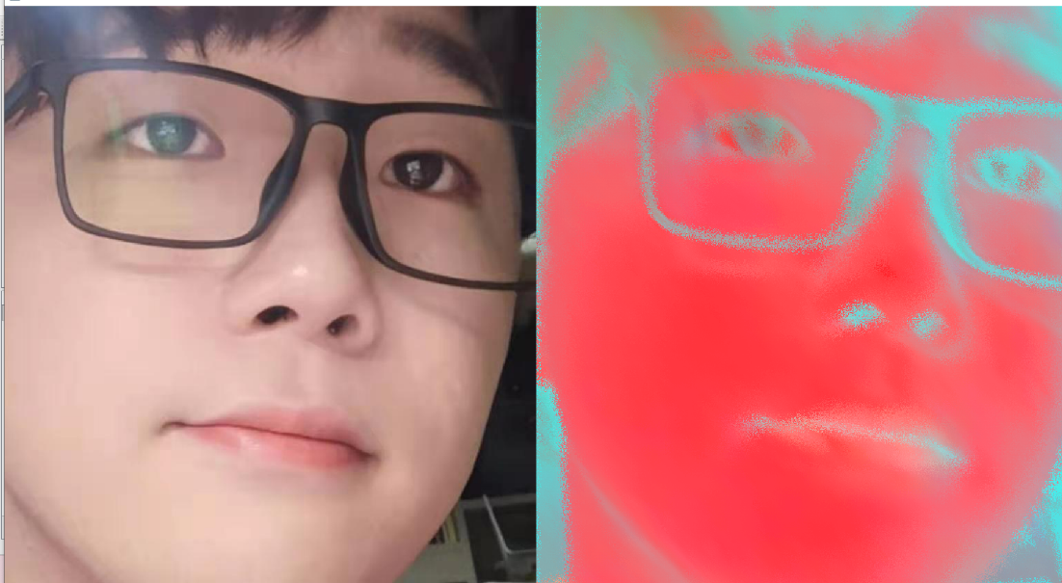

**Sample Picture 2 of Part B.2 Color Transform** : **(before/after)**

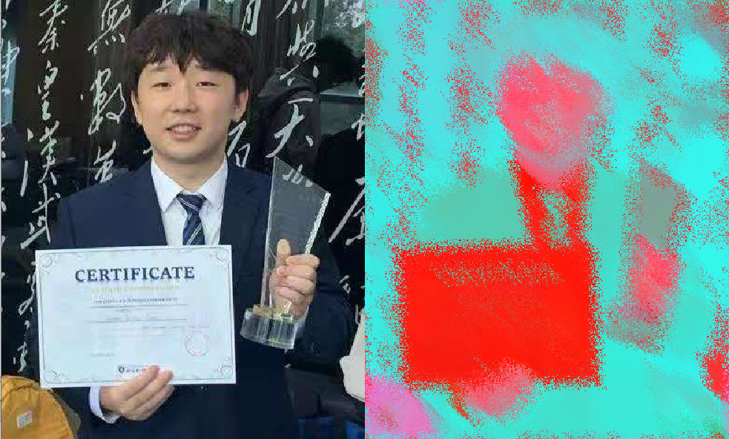

**Sample Picture 3 of Part B.2 Color Transform** : **(before/after)**

